..
Website automation  Let automation handle for you.  Activate automation technologies to automate tasks and interactions on your website via user interfaces (UI), from ERP,BPM,IPA,CRM,DPA and BPA | 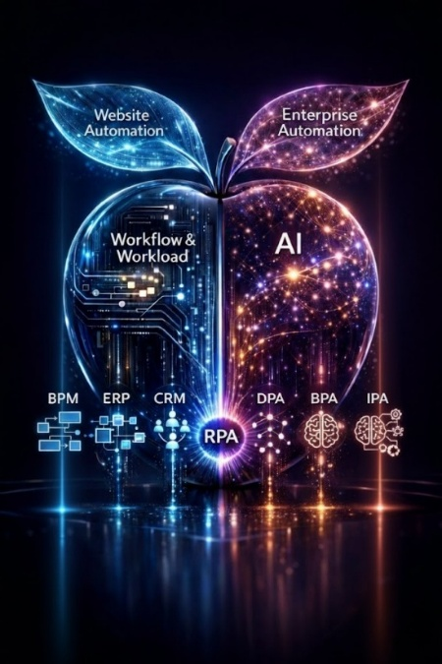
licenses
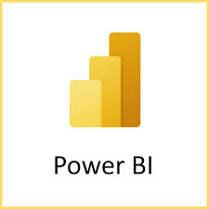
Imagine a world where back-office tasks disappear.
- Do you own a factory and need to upload/update production lists? We've automated this process.
- Do you own a retail business and need to share sales results in a timely manner? We've automated this process.
- Do you have a pricing report that needs to be extracted from multiple websites and converted into a daily report to be emailed to various stakeholders? We've automated this process.

Web Browser Automation  Let Robotic Process Automation (RPA) streamline your web browser tasks with greater speed and precision. It mimics human interactions—and goes even further.   |   automate web browser tasks  Browser & Web Automation: Tools, Methods & Python Examples - Crash
Get automation software to take control of your web browser. It replicates human actions—from keystrokes and mouse clicks to data extraction and scheduled report generation—and can even integrate non-UI processes, such as calling APIs.
Web Browser Automation Use Cases

Website Monitoring | Web Scraping and Data Extraction | Preparing a Report | Performance testing
Website Monitoring
Maintaining the integrity of a website is crucial for any brand. Automation is essential for tracking performance, uptime, and other key metrics, while alerting teams whenever an issue arises.
Common use cases include:
• Uptime monitoring: Ensuring the website is accessible and functioning correctly.
• Performance checks: Monitoring load speeds and identifying slow-loading pages.
• Content tracking: Detecting unauthorized changes or the loss of content on critical pages.
• Link verification: Scanning the site to identify broken or outdated links.
web scraping is a major ‘browser automation’ uses case, not all applications offer direct APIs for extracting available data.

Web browser automation solves the problem of extracting public data, transforming scattered information across the internet into structured datasets that teams can use and analyze..
Common use cases include:
• Price monitoring: checking competitor prices of e-commerce sites
• Market research: collecting reviews, product information, or listings for analysis
• News aggregation: collecting headlines or stories from various sources:

- Social sentiment and engagement data in the form of likes, shares, and posts on networks
- Digital commerce activity such as competitor pricing/advertising campaigns, product inventory/dynamic pricing strategies as well as user-generated item reviews on sites like eBay, Amazon, and Wish
- capture competitor discounts
- can have capture competitor discounts every morning, and a financial analyst can pull news feeds into one dashboard. The result is fresh data to faster time to decisions.
Illustrative Example  Preparing a single report might take about 10 minutes; however, doing so on a weekly, daily, or even hourly basis could consume hours of your day.  Consider the following steps:  - Launching a web application.  - Entering your username.  - Entering your password.  - Clicking the login button.  - Navigating to the reports section.  - Entering the current date.  - Clicking the report link.  - Saving the report to a designated folder on your network.  - Logging out of the site. |  | Web automation allows you to interact with websites and browser-based applications to execute repetitive tasks seamlessly. This makes the process more efficient and significantly less prone to errors than manual execution by humans.
Performance testing via stress tests:  Leverage browser automation capabilities to conduct "stress tests," which aim to simulate a high volume of traffic flowing to a specific domain and monitor how that domain handles the load.  Stress testing includes the following:  ➢ Load testing’: Ensuring that load times are up to par in an attempt .  ➢ Regression testing’ – i.e., ensure that live software is functioning properly, especially after an update has been pushed live .  ➢ Parallel/grid testing : Correlating and cross-referencing every possible browser and operating system to see how your program functions in that environment. |  | performance website testing,  The "OnWebApp" platform provides advanced tools for testing website performance, including link verification, performance efficiency testing, and data collection. Our tools assist in analyzing, cleaning, and structuring targeted data, which can then be delivered in various formats (such as JSON, CSV, HTML, or Microsoft Excel).

…
Front-End Automation  Build automation to simulate human interactions with user interfaces..  - Repetitive Task Automation.  - Customized customer journey automation.  - pre-defined business journeys automation |   Good Workflow for Automating Frontend Tasks
….
…
Customer Service Automation Build automation to simulate human interactions with user interfaces..  - Repetitive Task Automation.  - Customized customer journey automation.  - pre-defined business journeys automation |   Good Workflow for Automating Frontend Tasks

Website test Automation  Web application testing is repetitive in nature. Each new feature, bug fix, or update should be tested on different browsers and devices. Browser test automation saves time by running scripted tests to simulate a real user interaction in multiple browsers and allowing to run these tests in parallel. |   Website Testing: A Complete Guide  Automated Website Testing | Fortra

Dynamic State Management (DCM) techniques are gaining increasing importance in automating highly agile and high-risk processes within website and enterprise automation. DCM is closely related to automation techniques (PRA, BPA, DPA, IPA) for workflow automation and workloads Automation . Workflow automation focuses on automating repetitive tasks and user-centric processes through the user interface, while workload automation focuses on automating complex IT tasks centered around the system and IT infrastructure—"enterprise automation."

....

Web Browser Automating Tasks:
Top Web Browser Automation Use Cases (Real-World Examples) - Anchor

Data Extraction | Website Monitoring | Automated Dashboards
..
Front-End Automation - UI automation  UI automation provides the mechanisms to mimic human interactions with user interfaces s |  | 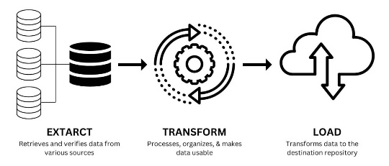
 | Common use cases | Practical Example | OnWebApp solution
Common use cases
- Controlling the mouse and keyboard to simulate user actions..

Practical example: Decision-making automation:
Many user interface actions are the result of human decisions, which are not necessarily recorded in the action itself. User interface automation takes over mouse and keyboard control to simulate user actions. Therefore, the user cannot work on the computer simultaneously.
OnWebApp solution
Enable robotic process automation (RPA) within workflow automation.
…
Data Extraction
Not all applications provide APIs that effectively extract data from the internet and transform it into structured, analyzable output.
Web browser automation addresses this issue by enabling automated systems to collect scattered data from the internet into structured datasets that teams can actually use..
 | Common use cases | Practical Example | OnWebApp solution
Common use cases include:
- Price Monitoring: Checking competitors' prices on e-commerce sites.
- Market Research: Gathering reviews, product information, or listings for analysis.
- News Aggregation: Gathering headlines or stories from multiple sources..
Practical example:

OnWebApp team has extensive experience designing custom automated dashboards to automate routine business management from different sources and integrate data into a single view. Explore automated dashboards.
..
Website Monitoring
Maintaining website integrity is critical for any brand. Manually checking website integrity is impractical, so we need automation to track website performance and notify teams when any issues arise.
 | Common use cases | Practical Example | OnWebApp solution
Common use cases include:
- Uptime monitoring: Ensuring the website remains online.
- Performance checking: Monitoring loading speeds and identifying slow pages.
- Content tracking: Identifying any unauthorized changes or missing pages on critical pages.
- Link checking: Searching for broken or outdated links. Scheduled checks ensure..
Practical example:
an e-commerce platform can automate a checkout simulation every hour. If a page slows down or a step fails, the system immediately notifies the support team. This protects sales and builds user trust.
OWA-website monitoring platform
..
Automated Dashboards
Many teams spend hours each week tracking cases, exporting files, and formatting reports.

The solution lies in automating a workflow to integrate data from various sources into a single view: an automated dashboard.
 | Common use cases | Practical Example | OnWebApp solution
Common use cases include:
- Accessing the portal: Logging into systems.
- Downloading reports: Exporting CSV, Excel, or PDF files according to a defined schedule.
- Dashboard updates: Integrating data from different sources into a single view.
- Distributing reports via email: Automatically sending periodic reports to stakeholders.
Practical example:
The finance team can schedule the collection of daily sales data, integrate it with marketing metrics, and send it to managers every morning. No need to log in, no need to export files, and numbers are delivered on time and in the correct format.
OnWebApp team has extensive experience designing custom automated dashboards to automate routine business management from different sources and integrate data into a single view. Explore automated dashboards.
..
Social Media Automation
Modern businesses use multiple social accounts. However, managing each manually makes it difficult and repetitive in the long run. Yet, posts need to go out on time, engagement has to be tracked, and reports have to be pulled together across all the social profiles. Automation can take care of these repetitive steps so teams can focus on creating content and refining strategy..
 | Common use cases | Practical Example | OnWebApp solution
Common use cases include:
- Post scheduling: line up content in advance and publish it automatically
- Engagement tracking: capture likes, comments, and shares without manual checks
- Multi-account management: handle several brand or client accounts from one workflow..
Practical example:
take a marketing team managing three channels. Instead of logging in daily, they schedule a week's worth of posts and get automated reports on engagement each day. Less clicking, more time spent improving campaigns..
OWA- Social Media platform

..

Front-End Automation

- UI automation | Repetitive Task Automation | Customized customer journey automation | pre-defined business journeys automation
..
UI automation
UI automation provides the mechanisms to mimic human interactions with user interfaces s

 | Common use cases | Practical Example | OnWebApp solution
Common use cases
- Controlling the mouse and keyboard to simulate user actions..

Practical example: Decision-making automation:
Many user interface actions are the result of human decisions, which are not necessarily recorded in the action itself. User interface automation takes over mouse and keyboard control to simulate user actions. Therefore, the user cannot work on the computer simultaneously.
OnWebApp solution
Enable robotic process automation (RPA) within workflow automation.
…
Repetitive Task Automation
Configure workflow automation to accomplish repetitive tasks; leverage Robotic Process Automation (RPA) capabilities to simulate human users and automate front-end and repetitive surface tasks..
 | Common use cases | Practical Example | OnWebApp solution
Common use cases
 | Function | Recipe
 | automating human processes | from data entry and data transfer to report creation and more..

Practical example:
OnWebApp solution
Enable robotic process automation (RPA) within workflow automation.
..
Customized customer journey automation
Build workflow automation recipes for your customized customer journey..
 | Common use cases | Practical Example | OnWebApp solution
Common use cases
 | Function | Recipe

Practical example:

OnWebApp solution
Enable robotic process automation (RPA) within workflow automation.
..
pre-defined business journeys automation  Set up workflow automation to create predefined customer paths. |  | 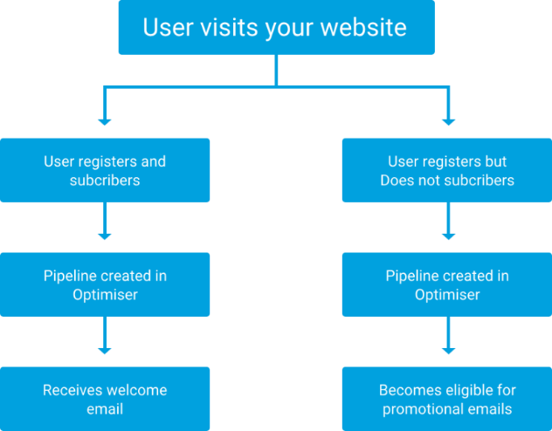
 | Common use cases | Practical Example | OnWebApp solution
Common use cases
 | Function | Recipe

Practical example:

OnWebApp solution
Enable robotic process automation (RPA) within workflow automation.

Customer Service Automation
AI Chatbot    Chatbots are based on Natural Language Processing (NLP) to understand common questions or refer them to the appropriate employee.. | Automate communication   Set up email, SMS, and WhatsApp automation to create ready-made messages for customers. |   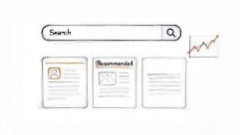  Automated Self-Service Knowledge  An automated, centralized digital library containing information about a specific product or service.
Proactive Customer Support   | follow-up and Escalating Unresolved Issues  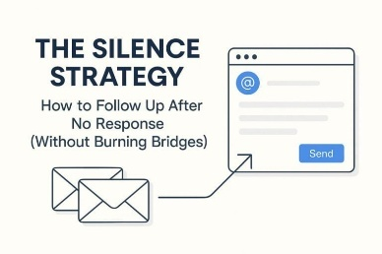  Follow up on unresolved issues and send automatic reminders to senior staff according to priority.  <<<< dashboard.>>>>> | lead Qualification    Create a lead Qualification workflow, classify the lead as a Marketing Qualified Lead (MQL), and automatically add their record to the CRM system.

..

WEB Security automation

Set up workflow automation to create predefined customer messages.

threat detection and response.

Build workflow automation with Intelligent Process Automation (IPA) technology to detect anomalous behaviors that indicate a cyber threat.

..
Web Testing Automation

Set up workflow automation based on DCM Technologies
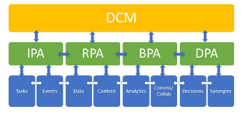

..
Go beyond simple, rule-based tasks and integrate DCM technologies (PRA, BPA, DPA, IPA) with the power of AI to enhance workflow automation from simple to complex tasks across websites and integrated systems.
(RPA) Robotic Process Automation | (IPA) Intelligent process automation | (BPA)  Business Process Automation | (DPA)  Digital Process Automation
Robotic Process Automation (RPA)  Robotic Process Automation (RPA) is a key component of large-scale workflow automation, thanks to its ability to automate repetitive and user-interface tasks based on predefined rules. These bots mimic human actions by interacting with digital systems (such as enterprise resource planning systems and business-to-business systems) to execute business processes, process and extract data from various systems, generate reports, and perform a wide range of other automation tasks. Explore RPA, its types, and its applications in workflow and business automation. |  |  | RPA  What is Robotic Process Automation? | RPA Processes | Hyland
Intelligent process automation (IPA)  Intelligent Process Automation (IPA) integrates Robotic Process Automation (RPA) technology with Artificial Intelligence (AI) to automate complex and comprehensive business processes. Unlike RPA, which relies on rigid programming rules, IPA thinks, learns, and adapts independently.  By combining AI technologies such as Machine Learning (ML) and Natural Language Processing (NLP), IPA extracts valuable insights, understands unstructured data, interprets its content, extracts meaning, and makes decisions that are difficult to program manually.  Example 1: Reading emails and determining whether they represent a customer problem, a sales opportunity, or should be ignored until the end of the week.  Example 2: Crafting customer communication messages and responses based on sentiment analysis whenever a new prospect enters your CRM system.  Delve into IPA(Rev.Intelligent process automation (IPA) |  |  | 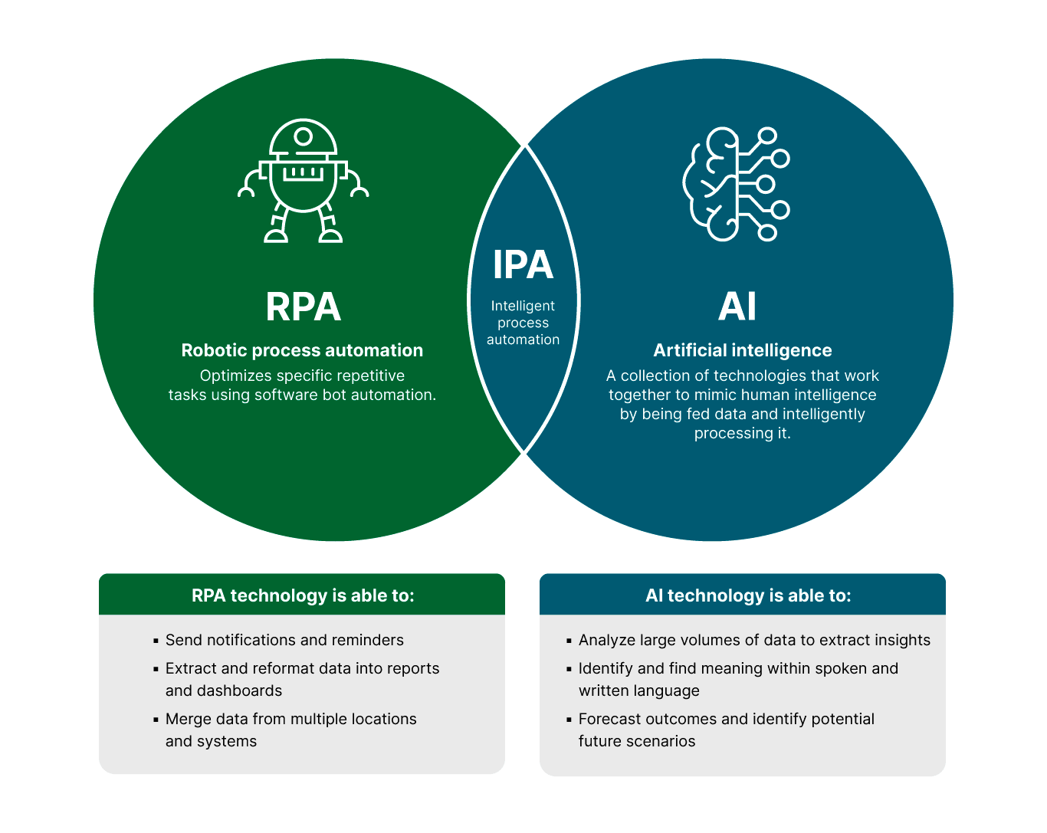
Business Process Automation (BPA)  Business process automation goes beyond the IT department. It executes complex, multi-step transactions and workflows with minimal human intervention. BPA focuses on coordinating end-to-end processes across multiple IT departments and systems, where each workflow step automatically triggers the next, automating all your business functions.. |  |  | Business Process Automation (BRA)
Digital Process Automation (DPA)

Comprehensive management of business workflow across multiple systems and departments for human decision-making.

..
..
Business areas were website automation
Marketing operations | Sales | finances | Accounting | eCommerce | Social media manager | Cybersecurity
..
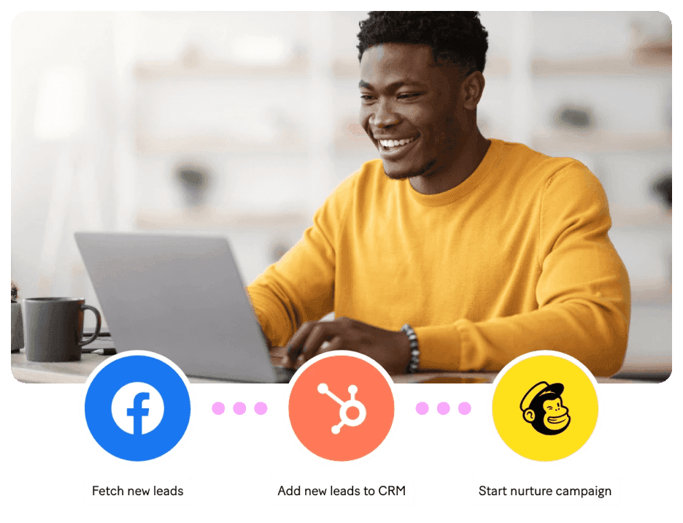 | Marketing operations  The marketing operations team manages the hidden aspects of any marketing campaign, such as lead management and evaluation, data collection and tracking, and much more. workflow automation allows you to automate these tasks, synchronize data with CRM systems and other systems, automatically schedule social media posts.  Marketing Automation Software | Solutions & Examples | Make
   | 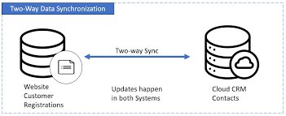 | 
  Automating Marketing Campaigns | Systems Data Synchronization | Data Collection and Tracking

Use case & automation recipes
Lead Management  - Collecting data on potential customers  - Customer segmentation for targeting marketing campaigns | Subscriber Segmentation  Segmenting the audience immediately upon joining. | Data Cleanup  - Data formatting  - Data cleaning and early error detection

..

Workflow automation recipes:
- Lead management: Collecting data on potential customers and classifying them for use in managing marketing campaigns.
- Segmenting subscribers: Segmenting subscribers immediately upon joining to send the right message to the right audience.
Accounting: | - Automating accounts payable  - Automating collections  - Automating invoices  - Automating financial accounting.
➢ manufacturing : | - Managing the production process, from inventory management to tracking every step of the production process.
Human Resources (HR): | - Automating the recruitment process  - Automating payroll processing  - Tracking employee performance indicators.

.. …

Explore IT automation solutions for various sectors

  IA and RPA for Manufacturing Automation | SS&C Blue Prism |  |   IA & RPA Solutions for Energy & Utilities Automation | SS&C Blue Prism |  |   Transportation & Logistics Automation | SS&C Blue Prism
supply chain |  | logistics |  | How AI and RPA are transforming the supply chain and logistics industries - Covrize
  Add Retail Automation to Your Cart | RPA E-Commerce & Retail | SS&C Blue Prism |  |   Financial Services AI Automation With RPA | SS&C Blue Prism | SS&C Blue Prism |  | IA and RPA for Telecom Automation | SS&C Blue Prism
..

..

Get monthly insights

Take Your Automation to the Next Level
Looking for more? Let’s talk about how we can help.

CONTACT US

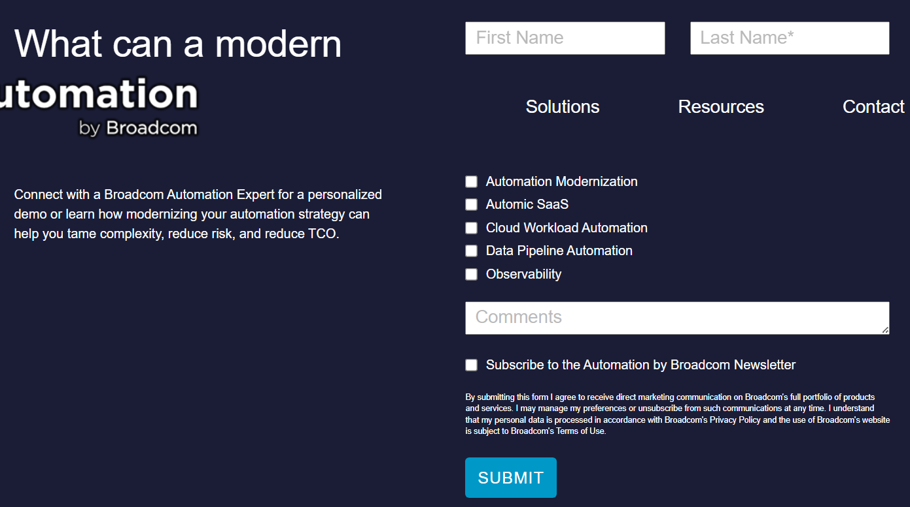

Related
  How to Keep Your Website Safe from Hackers | How to Make Your Website User-Friendly Before the New Year | Website First Impressions: Before They Know You, They Judge You by Your Website
End-of-Year Website Fixes Every Business Should Do Before January | Managing Multiple Websites: Tips for Efficient Web Hosting | 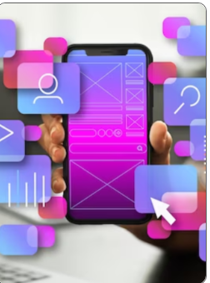  Website Optimization for Seamless Mobile Experiences

END OF FILE
..
autonomous marketing platform  $49 /mo |  |  | Web Automation Guide for 2024 | Web Automation: Tools, Examples and Guide for 2024
Website Automation | Web Automation with RPA | Automate
elf-Service Automation for All | Universal Portal | Self-service Automation for All Users |  | 20 Best Web Automation Tools Reviewed for 2025 | 20 Best Web Automation Tools Reviewed for 2025
Automation Testing | Katalon AI-augmented Test Automation Platform |  | Enterprise Automation | Enterprise IT Automation: A Holistic Approach | Fortra

Dynamic Case Management | Mendix
What Is Workload Automation Observability?

Workload Automation: Transforming Business Processes
5 Ways Workload Automation Can Accelerate Digital Transformation – BMC Software | Blogs

Web automation examples and use cases
Web Automation: Tools, Examples and Guide for 2024
How to Automate ServiceNow: Test and Process Automation
What is a web service?
Enable your customers to access data and functions without the need for any downloads or installations.
A web service is a piece of code created using a standardized protocol and available on an internet-connected device. The web part of a web service defines how it can be accessed from any environment; the service part provides access to functionality without requiring any downloads or installations.
Think of the relationship between a user and a web service as the relationship between a service user and a service provider. When a user needs specific information, they contact the service provider to obtain it. All the user sees is the end result—they are not concerned with the details or the process of obtaining the information.

